Telephonics Shipment and Packaging Instructions
TCX1138

SELLER Packing/Marking/Bar Coding/Shipping Instructions

SELLER Packing
SELLER shall be responsible for ensuring proper packaging per ASTM-D-3951-15 Standard Practice for Commercial Packaging. Any item requiring ESD protection must be packaged in accordance with Mil-Std-2073-1E.
All units shall be individually packed and wrapped in ESD protective packaging and placed in outer ESD protective boxes with proper lining (reference figures 1 and 2 below). Both internal ESD protective wrapping and outer ESD protective boxes shall be identically labeled/marked as specified below in “SELLER Marking/Barcoding” requirements (reference figure 3 of sample barcode label).
Certificates of Conformance (C-of-Cs) and Packing Slips shall be attached to the outside of the shipping container in a water-tight clear plastic envelope. The container with the C-of-C and pack slip shall be clearly identified when there are multiple shipping containers and each container should be clearly marked as “1 of X”, “2 of X”, etc. All serialized assets shall be clearly identified/posted on the outside of the respective shipping container.
The accompanying pack slip, and C-of-C should include the following information, at a minimum: PO number and line item numbers, TTM part (item) numbers and revision, and applicable S/Ns. If the item is a repair, then the RMA number and NCR number shall additionally be noted.
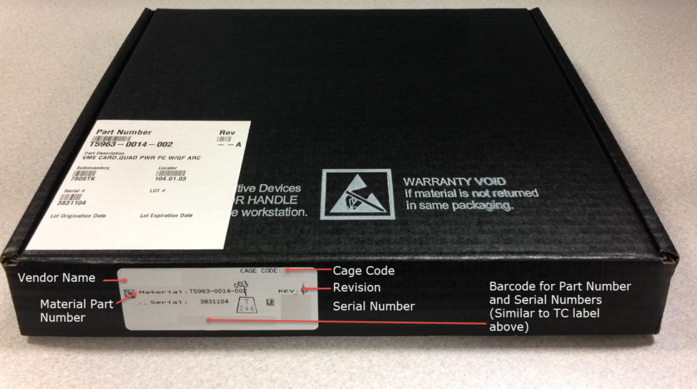
Figure 1 - Sample ESD Outer Protective Box
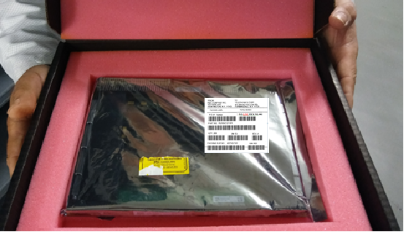
Figure 2 - Sample ESD Protective Wrapping of Unit (with Label on Wrapping) Contained in Outer ESD Protective Box with Inner ESD Protective Lining

SELLER Marking/Barcoding/Labeling
SELLER shall mark containers or packages per TTM’s barcode/labeling instructions outlined below in Figure 3 to include shipper address, consignee address, purchase order number, line-item numbers, TTM’s part (item) numbers and revision, quantity, unit of measure, packing slip number and serial numbers (if applicable). Bills of lading shall include purchase order number. Where and when possible, apply barcode labels to the upper left-hand corner of the shipping box. Failure to properly barcode/label packages may result in processing delays and result in delay of payment to the SELLER. A sample barcode/label is provided below. The barcoding shall be legible and of proper font and format so as to allow barcode readers to easily identify information (reference MIL-STD-129 for guidance).
P.O. LINE ITEM NO. 001
Figure 3 - Sample Barcode Labeling

SELLER Shipping Instructions
Domestic Shipments:
Unless otherwise specified, delivery shall be FOB Destination shipped via C-TPAT Certified Carrier per TTM Farmingdale’s Terms and Conditions.
International Shipments:
New Goods for Permanent Import into the U.S.
Unless otherwise specified, delivery shall be DAP Farmingdale, NY (Incoterm 2010) and shipped via C-TPAT Certified Carrier per TTM Farmingdale’s Terms and Conditions.
A complete commercial invoice shall accompany all shipments and contain complete information per U.S. Code of Federal Regulations 19cfr141.86 Contents of Invoices and General Requirements.
Goods being shipped may fall under the jurisdiction of the U.S. Department of State International Traffic in Arms Regulations. Please follow PO instructions for all shipments and contact the TTM Supply Chain Specialist with any questions.

Repaired Goods
Unless otherwise specified, delivery shall be DAP Farmingdale, NY (Incoterm 2010) and shipped via C-TPAT Certified Carrier per TTM Farmingdale’s Terms and Conditions.
Goods Being Returned after Repair may fall under the jurisdiction of the U.S. Department of State International Traffic in Arms Regulations. Please follow PO instructions for return shipments and contact the TTM Supply Chain Specialist with any questions.
Goods for Temporary Import into the U.S.
Goods for temporary import into the U.S. may require prior authorization of the U.S. Department of State. Please follow PO instructions for shipments and contact the TTM Supply Chain Specialist with any questions.
Revision History
Rev | Description | Date
A | Original Issue | 4/2/2020
B | Rebrand | 07/02/2025
C | Removed Huntington and added Farmingdale | 02/13/2026

